- Verbinde
E ….
I - -
S .
H - - -
5 …..
T - - - -
M ..
O - - - - -
CH -
- …

- Schreibe die Merkwörter hinzu.
A _________________________________ B ____________________________________
C _________________________________ D ____________________________________
F _________________________________ G ____________________________________
H _________________________________ I ____________________________________
J __________________________________ K ___________________________________
L __________________________________ M___________________________________
- Womit kann man Morsen? Schreibe die Bilder an.

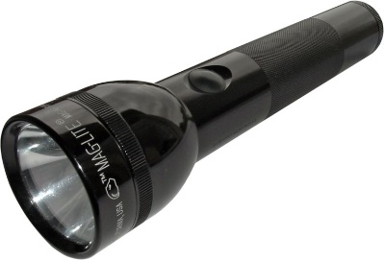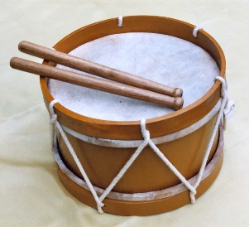
________________________________________________________________________
- Entschlüssle mit Hilfe des Morsen Schlüssel die folgende Botschaft
…/.-/ - -/ . . -/ ./ .-..// - -/ - - -/.-./ …/.// .- - - -/ - - - . ./…../ - - …//
________________________________________________________________________

